Java Collection Challenge
Main Menu:
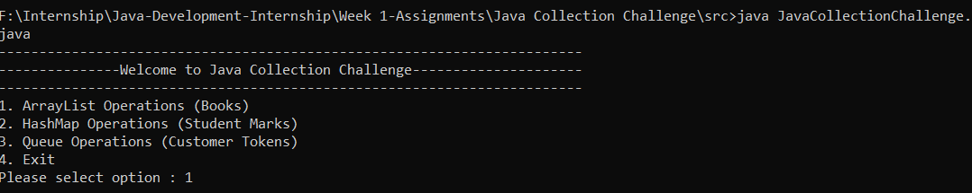
1.ArrayList Operations(Books)
1.Add Book:
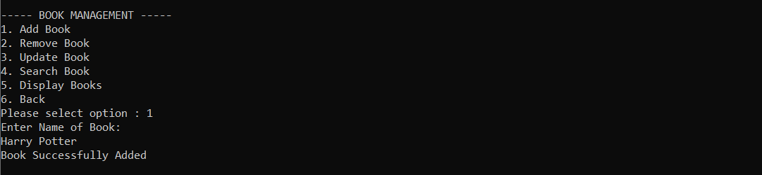
2. Update Book:
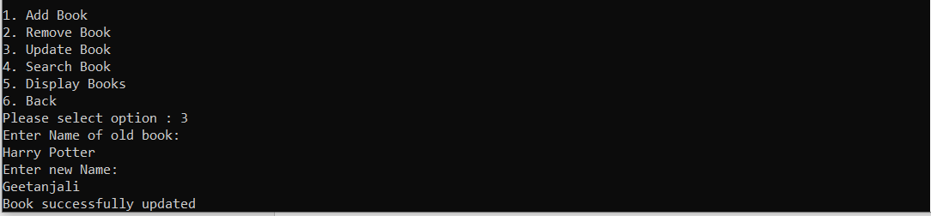
3.Search Book:
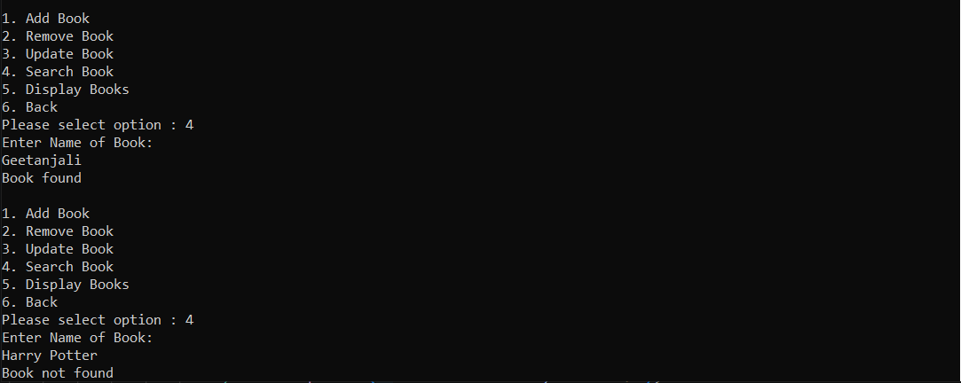
4. Display Books:
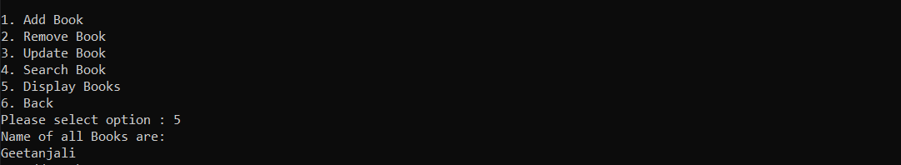
5. Remove Books:
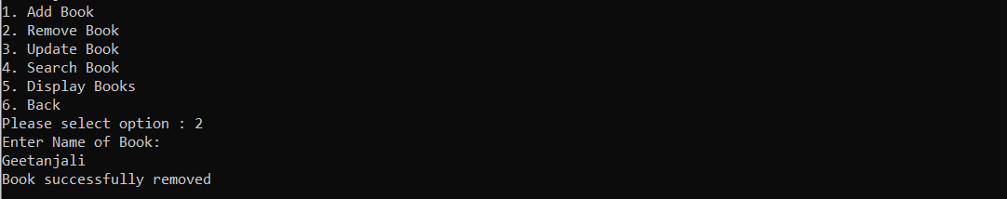
6.Back to main menu:
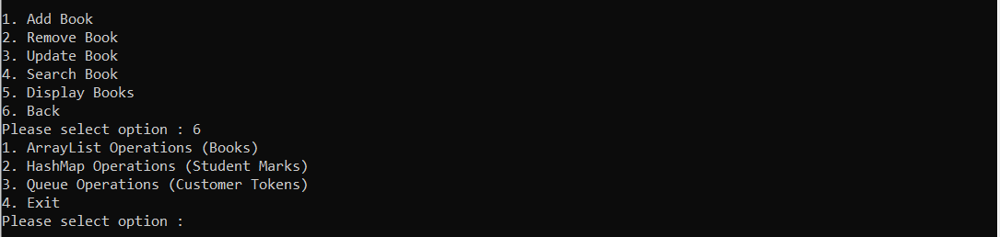

2 HashMap Operations(Student Marks):
- Add Student:
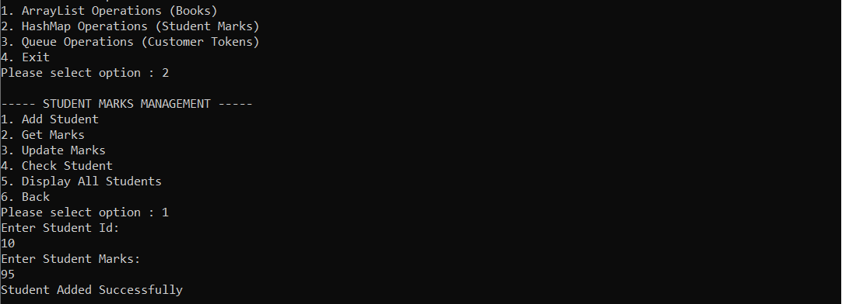
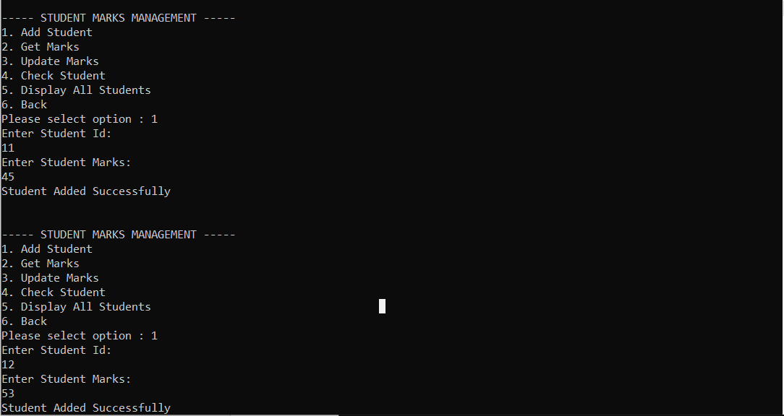
- Get Marks:
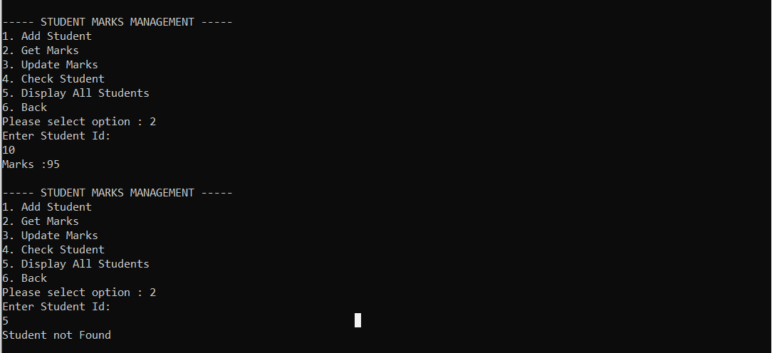
3.Update Marks:
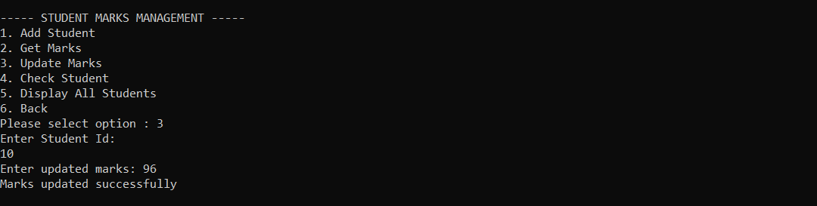
4. Check Student:
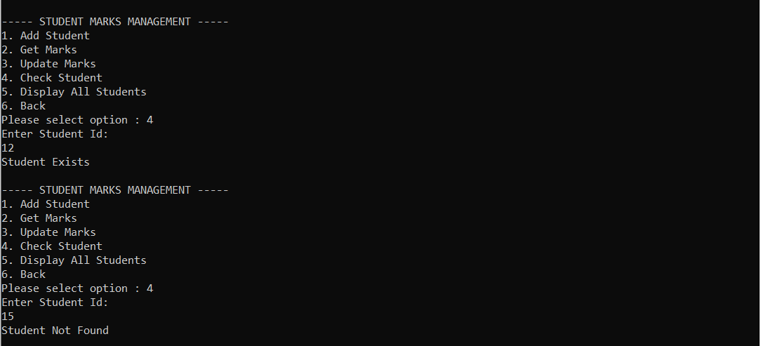
5. Display All Students:
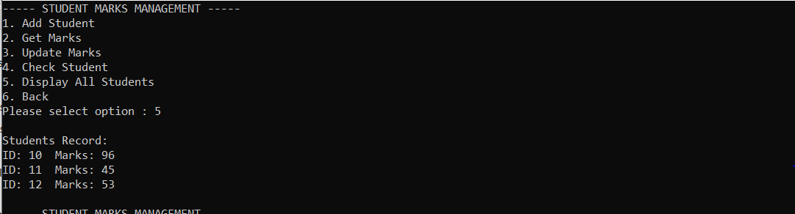
6. Back to main menu:
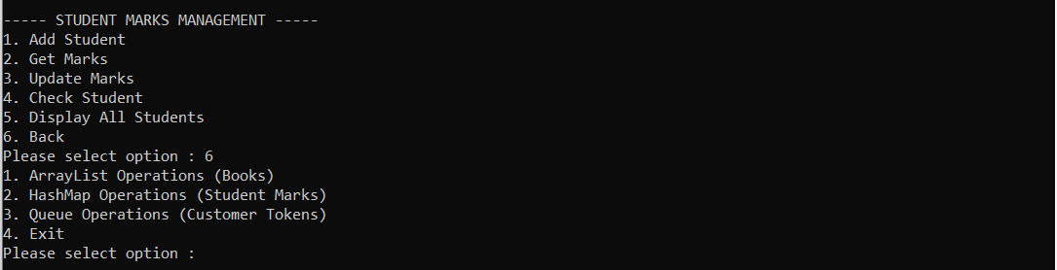

- Queue Operations(Customer Tokens):
1.Add a customer:
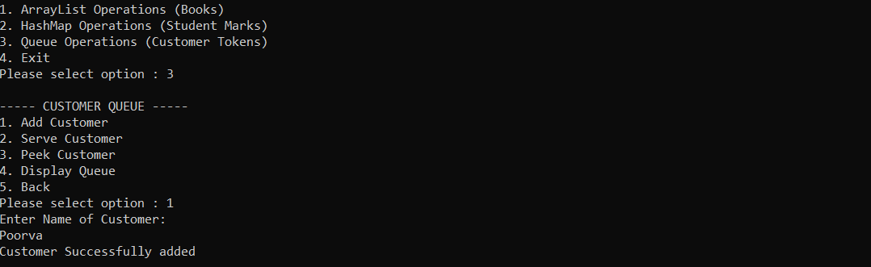
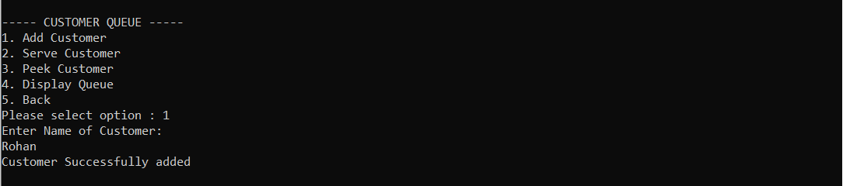
- Serve Customer:
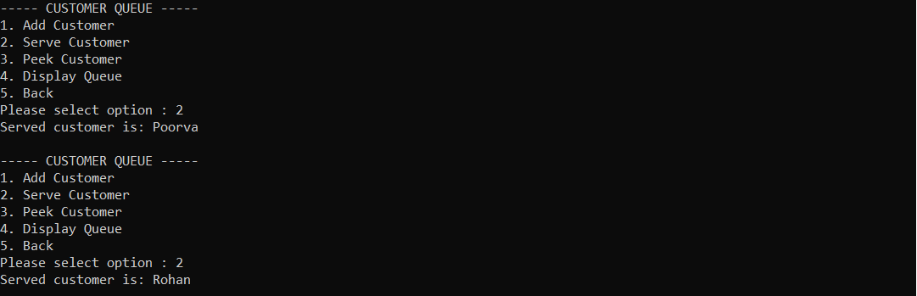

- Peek Customer:
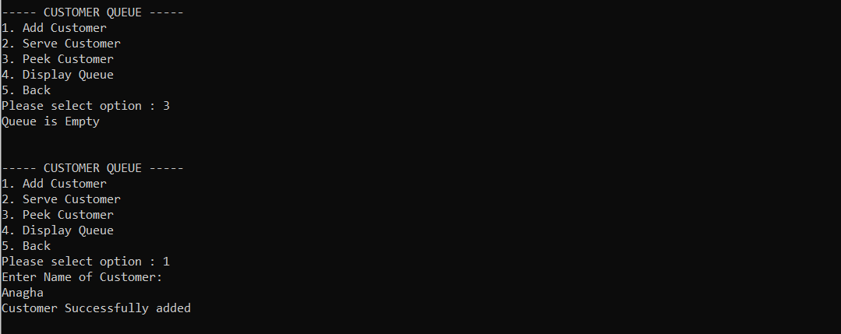
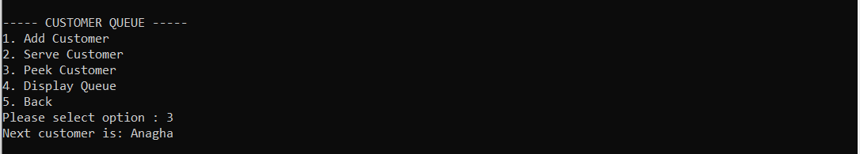
- Display Queue:
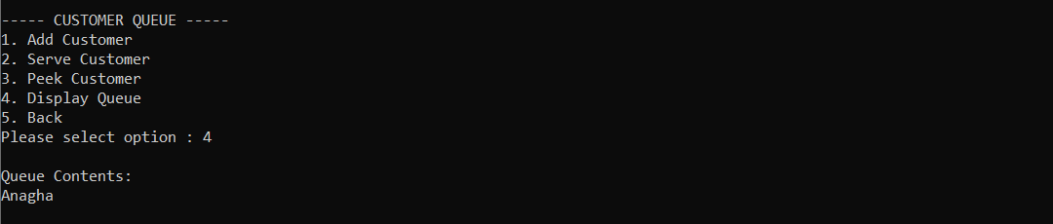
5.Back to main menu:
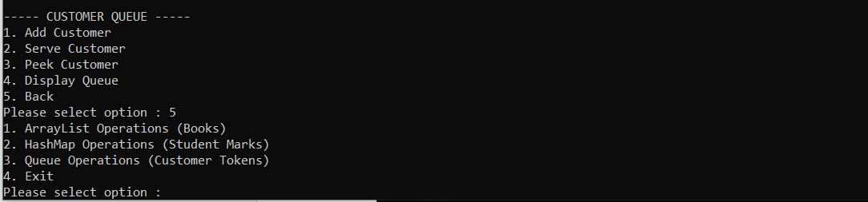
- Invalid Input:
